UI DESIGN AND FRONTEND IMPLEMENTATION REPORT
Group 7 · Faculty of Engineering and Technology · University of Buea · 2025/2026

1 Application Identity

1.1 Application Name and Purpose
NetPulse Crowdsense is a mobile-based crowdsourced network monitoring application developed to collect, analyze, and visualize mobile network performance data from user devices. Unlike traditional network auditing approaches that rely on expensive drive-testing equipment and specialized personnel, the proposed solution leverages community participation to gather network measurements in real time.
The application enables users to monitor signal quality, perform network performance tests, submit connectivity reports, and contribute location-based measurements that are aggregated into a centralized database. These measurements are subsequently used to generate coverage maps and provide insights into network performance across different geographical regions.
The primary objective of the application is to provide a cost-effective and scalable approach to mobile network assessment while encouraging user participation through a simple and intuitive mobile interface.

4.1.2 Design Philosophy
The design of NetPulse Crowdsense was guided by four fundamental principles:
Simplicity:
The application presents complex telecommunications metrics in a format that can be understood by both technical and non-technical users. Technical data is organized into visual cards and clearly labeled sections to reduce complexity.
Clarity:
Information is displayed using strong visual hierarchy, color-coded indicators, and concise descriptions. Critical metrics such as signal strength, download speed, upload speed, and latency are highlighted prominently to support quick decision-making.
Consistency:
A unified design language is maintained across all screens. Consistent spacing, typography, colors, and navigation patterns help users interact with the system without needing to relearn interface behaviors.
Accessibility:
Responsive layouts, readable typography, and touch-friendly controls ensure usability across a wide range of device sizes and operating conditions.

1.2 User Interface Design

1.2.1 Design Process
The interface design process followed a structured workflow that transformed system requirements into fully functional mobile screens.
The design phase began with requirement analysis derived from the Software Requirements Specification (SRS). Functional requirements were translated into screen-level workflows before high-fidelity visual prototypes were developed using Stitch AI.
The resulting designs were evaluated for usability, visual consistency, and information density before being converted into React Native components.
The overall workflow followed the sequence shown below:
Requirement Analysis → Wireframing → High-Fidelity Prototyping → Design System Definition → React Native Implementation → Testing and Refinement
This iterative process ensured that the final implementation remained aligned with the original project objectives while maintaining usability standards.

4.2.2 Layout Architecture
The application adopts a card-based interface architecture that separates information into logical sections. This approach improves readability and prevents users from becoming overwhelmed by large amounts of technical data.
Each major screen follows a three-layer structural layout:

Top Application Bar
The top navigation bar serves as the primary orientation element within the application. It displays:
- Application branding
- Screen titles
- Synchronization status indicators
- Contextual actions
The synchronization indicators provide users with real-time feedback regarding data uploads and background monitoring activities.

Main Content Area
The content area occupies the largest portion of the interface and contains the primary functionality of each screen.
Examples include:
- Signal monitoring dashboards
- Speed test visualizations
- Interactive coverage maps
- User reporting forms
- Historical measurement records
The content area uses vertical scrolling to accommodate varying data volumes without affecting navigation consistency.

Bottom Navigation System
A persistent bottom navigation bar provides direct access to the application's core modules:
- Home
- Map
- Speed Test
- Reports
- Profile
This navigation model was selected because it aligns with established mobile usability standards and supports one-handed interaction.

4.2.3 Screen Design Overview

Home Dashboard
The Home Dashboard serves as the primary entry point into the application.
It provides users with an immediate overview of network conditions through:
- Current signal strength
- Connectivity status
- Active monitoring indicators
- Quick-access actions
- Recent network activity
Large typography and visual status indicators allow users to assess network quality at a glance.
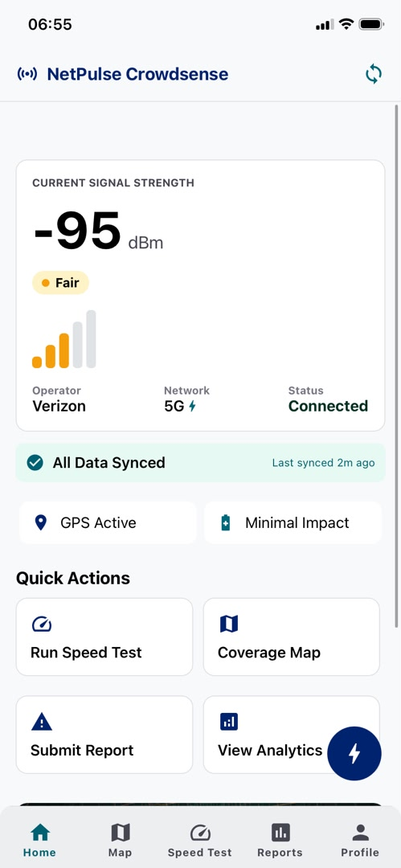

Network Monitoring Screen
The Network Monitoring screen provides detailed technical measurements collected from the device.
Displayed parameters include:
- RSRP (Reference Signal Received Power)
- RSRQ (Reference Signal Received Quality)
- RSSI (Received Signal Strength Indicator)
- SINR (Signal-to-Interference-plus-Noise Ratio)
- Cell Identifier Information
- Frequency Band Information
These values are grouped into structured cards that simplify interpretation while maintaining technical accuracy.
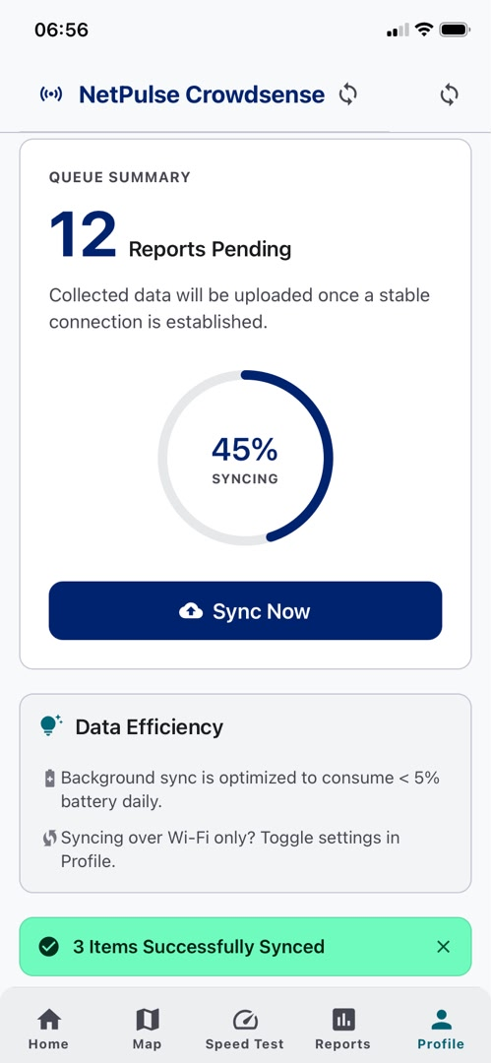

Coverage Map Screen
The Coverage Map screen transforms collected measurements into geographical insights.
Key features include:
- Interactive map visualization
- Coverage heatmaps
- Signal strength overlays
- Measurement markers
- Geographic clustering
This screen enables users to identify weak coverage zones and compare network performance across different locations.
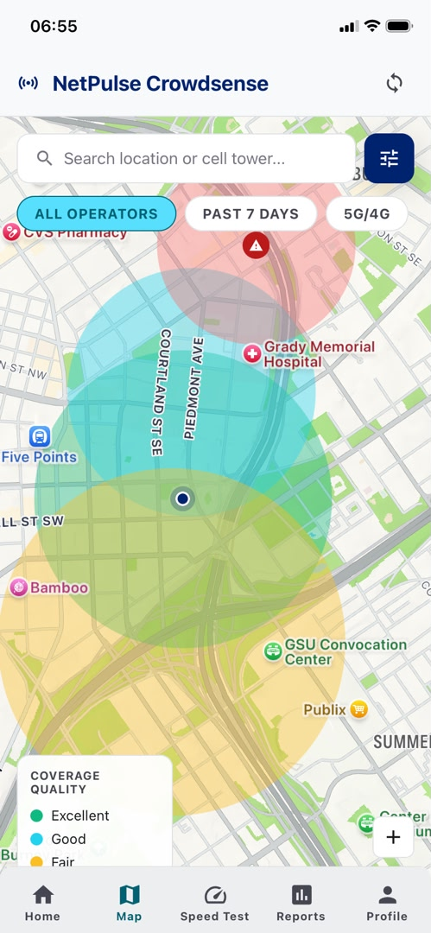

Speed Test Screen
The Speed Test module evaluates network performance through active testing.
Metrics measured include:
- Download Speed
- Upload Speed
- Network Latency
- Connection Stability
Animated progress indicators and real-time result updates provide users with immediate feedback during test execution.
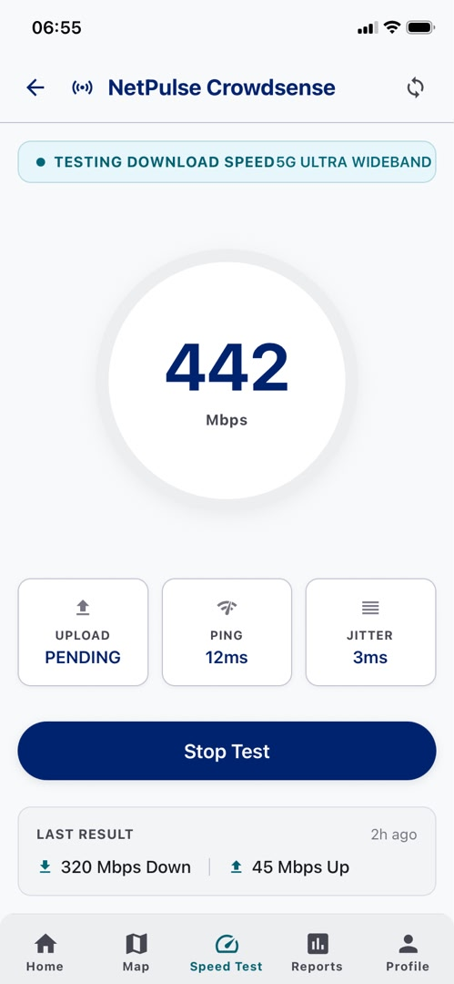

Reports Screen
The Reports module allows users to submit network issues and feedback.
The reporting workflow was intentionally simplified to encourage participation. Most information is automatically captured by the application, reducing the amount of manual data entry required from users.
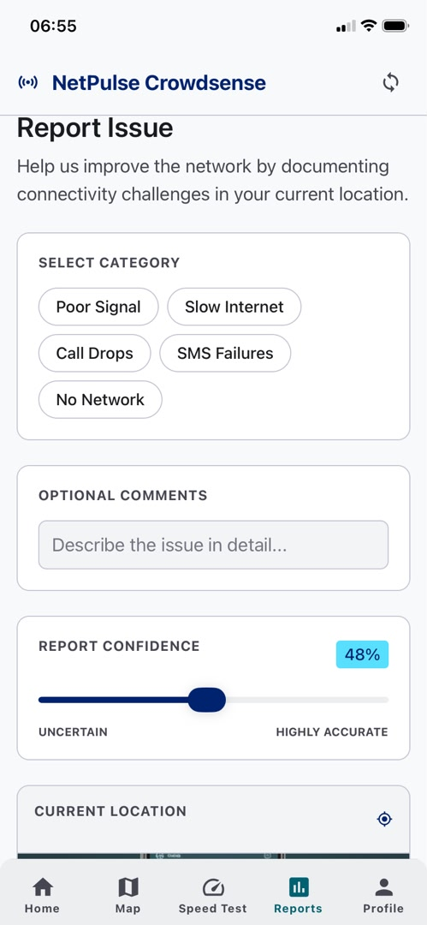

4.3 Visual Design System

4.3.1 Color Scheme
The visual identity of NetPulse Crowdsense is built around a technology-oriented color palette designed to communicate reliability, trust, and data precision.

Primary Blue (#00236F)
Used for:
- Brand identity
- Navigation highlights
- Primary buttons
- Important metrics
- Structural interface elements
The color conveys professionalism, stability, and technical competence.

Secondary Cyan (#57DFFE)
Used for:
- Active states
- Interactive feedback
- Data visualization accents
- Progress indicators
This color reinforces themes of connectivity, speed, and innovation.

Neutral Background Colors
White and light-gray tones are used extensively throughout the interface to:
- Improve readability
- Separate content sections
- Reduce visual clutter
- Enhance content hierarchy
The combination creates a clean and modern user experience suitable for data-intensive applications.

4.3.2 Typography
Typography plays a critical role in ensuring readability across various device sizes.
The application utilizes the Inter font family due to its excellent screen readability and modern appearance.
The typography hierarchy consists of:

Display Text
Used for:
- Download speeds
- Upload speeds
- Signal strength values
- Major performance indicators
Large font sizes help users identify critical information immediately.

Heading Text
Used for:
- Section titles
- Card headers
- Navigation labels
Medium and bold font weights improve content organization.

Body Text
Used for:
- Descriptions
- Instructions
- Supporting information
Optimized line spacing improves readability during extended use.

Technical Data Typography
Monospaced fonts are used for displaying:
- Cell IDs
- Frequency values
- Device identifiers
- System-generated codes
This distinction helps users differentiate technical information from standard application content.

1.4 Frontend Implementation

1.4.1 Technology Stack
The NetPulse Crowdsense frontend was developed using the following technologies:
Technology | Purpose
React Native | Cross-platform mobile application development
TypeScript | Static typing and code reliability
Expo SDK 54 | Development environment and runtime management
React Navigation | Screen navigation and routing
React Hooks | State and lifecycle management
The selected technology stack supports rapid development while maintaining high performance and scalability.

1.4.2 React Native Architecture
The frontend follows a modular architecture designed to promote maintainability and code reuse.
The project structure is organized as follows:
src/
├── screens/
├── components/
├── navigation/
├── services/
├── hooks/
├── utils/
├── assets/
└── constants/
Each directory serves a specific purpose within the application architecture.

Screens
The screens directory contains the primary application views, including:
- Home Screen
- Monitoring Screen
- Speed Test Screen
- Reports Screen
- Profile Screen

Components
Reusable UI components are stored separately to reduce duplication.
Examples include:
- Custom Cards
- Buttons
- Headers
- Loading Indicators
- Metric Tiles
- Navigation Elements

Navigation
Navigation logic is managed independently through React Navigation.
This separation improves scalability and simplifies route management.

Services
The services layer handles:
- API communication
- Data synchronization
- Speed test operations
- Background telemetry processing

Hooks
Custom React Hooks encapsulate business logic and state management functionality, improving component readability and maintainability.

1.4.3 Navigation System
The application implements a hybrid navigation architecture consisting of:

Bottom Tab Navigation
Used for primary application modules:
- Home
- Map
- Speed Test
- Reports
- Profile

Stack Navigation
Used for:
- Detailed views
- Settings pages
- Form workflows
- Modal screens
This combination provides both efficient navigation and flexibility for future expansion.

1.4.4 State Management
State management within the application relies primarily on React Hooks.
Key hooks include:
- useState()
- useEffect()
- useMemo()
- useCallback()
This approach keeps the application lightweight while ensuring predictable component behavior.
State is localized whenever possible to reduce unnecessary re-rendering and improve performance.

1.4.5 Responsiveness and Performance Optimization
To ensure compatibility across different devices, the interface was developed using responsive design principles.
The implementation utilizes:
- Flexbox layouts
- Percentage-based dimensions
- Dynamic spacing
- Adaptive containers
Several optimization strategies were also implemented:

Component Memoization
React memoization techniques reduce unnecessary rendering when telemetry data updates frequently.

Lazy Loading
Large datasets and historical records are loaded incrementally to minimize memory consumption.

Efficient Re-rendering
Custom hooks isolate frequently changing state from static interface elements, reducing computational overhead.

Lightweight Navigation
Screens are mounted only when required, reducing memory usage and improving startup performance.
Collectively, these optimizations help maintain smooth user interactions and consistent frame rates, even on lower-end mobile devices.

1.5 Summary
The NetPulse Crowdsense mobile application combines a modern user-centered interface with a scalable frontend architecture. Through the use of React Native, TypeScript, Expo SDK 54, and React Navigation, the system delivers a responsive and maintainable mobile experience.
The user interface was designed to transform complex cellular network measurements into understandable visual insights through the use of card-based layouts, intuitive navigation patterns, consistent typography, and carefully selected color schemes.
By emphasizing usability, performance, scalability, and accessibility, the frontend implementation provides a strong foundation for future enhancements while successfully supporting the objectives of crowdsourced mobile network monitoring.

Web Dashboard Implementation
Project Setup
The web dashboard is built with React 18, TypeScript, and Vite. Vite provides near-instant hot module replacement during development and optimised production builds with tree-shaking and code splitting.

The project was scaffolded using:
npm create vite@latest crowdsensed-web -- --template react-ts
cd crowdsensed-web
npm install

Dashboard Pages
The web dashboard consists of the following pages:

Page | Key Features
Login Page | Authentication form with role-based access, "Remember me", and password visibility toggle. Two pre-seeded demo accounts (admin and MTN operator).
Dashboard Overview | Summary stat cards (total users, samples, reports, coverage area), signal trend area charts, network type pie chart, hourly sample volume bar chart, and operator performance bar chart.
Coverage Map | Interactive Leaflet map with OpenStreetMap tiles. Heatmap and marker modes. Filters for operator and date range. Signal quality legend.
Network Analytics | Three-tab analytics page: Signal & Coverage (line chart, area chart), Operator Performance (radar chart, bar chart), Usage Patterns (24-hour area chart).
User Management | Searchable, paginated user table with role and status filters. User details modal. Suspend/activate user actions.
Report Management | Filterable report table with approve/reject actions. Confidence score progress bars. Status badges.
Coverage Intelligence | Weak and strong coverage zone cards derived from aggregated data. Multi-operator bar chart by geographic zone. Radar comparison chart.
Data Export | Dataset selector (samples, reports, users, analytics), date range and operator filters, field selector with select-all/clear, format selector (CSV / JSON / Excel), and download.
Settings | Theme, dashboard preferences, notification toggles, auto-refresh interval slider, and about information.
Profile | Editable profile fields, password change form, active session manager.

6.3 State Management
Application state is managed using Redux Toolkit with six slices:

Slice | Responsibility
authSlice | Authentication state, login/register thunks, session persistence via localStorage
dashboardSlice | Summary statistics, signal trends, operator stats, network distribution, date range selection
mapSlice | Coverage point data, map filters (operators, network types, signal range, view mode)
reportsSlice | Paginated report list, search/filter state, approve/reject actions
usersSlice | Paginated user list, search/filter state, selected user for modal, status updates
settingsSlice | Theme, notification preferences, dashboard preferences, localStorage persistence

Login Page:
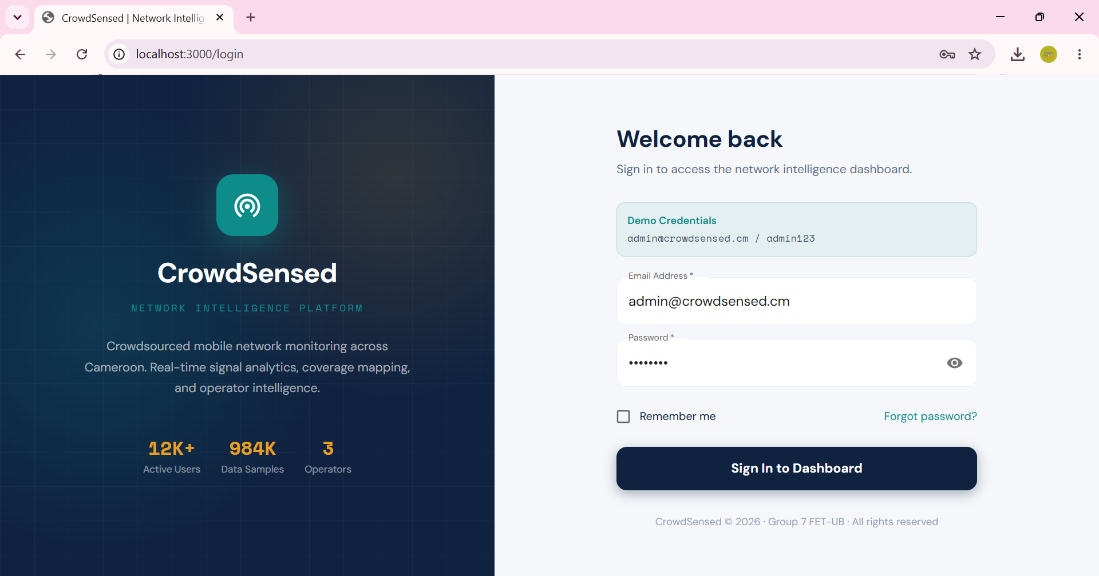

Dashboard — Overview page with stat cards and charts:
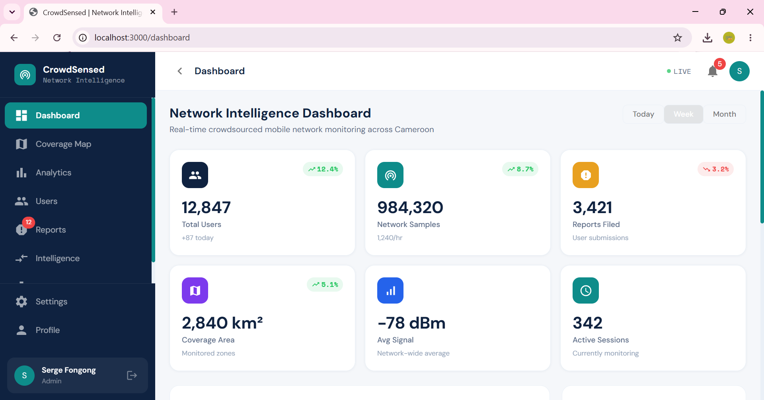

Coverage Map with heatmap overlay page
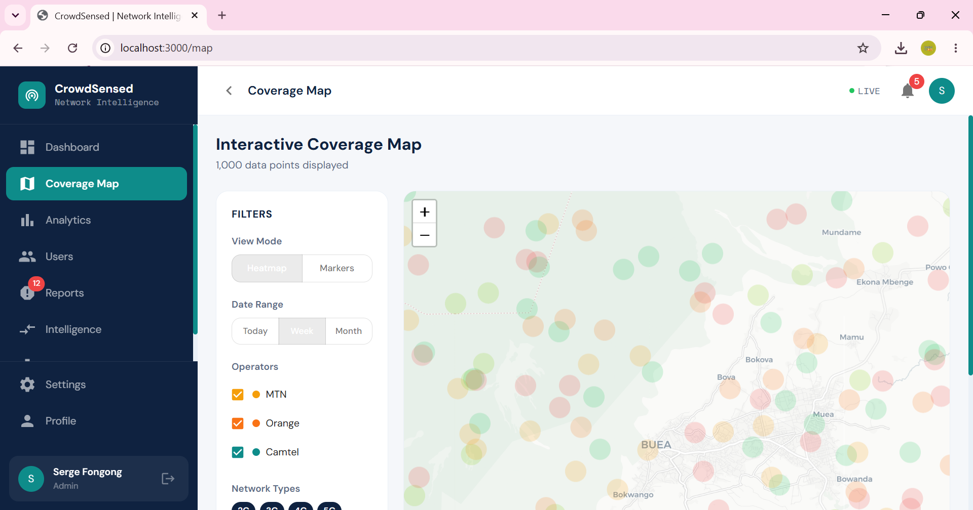

Analytics page showing radar chart page
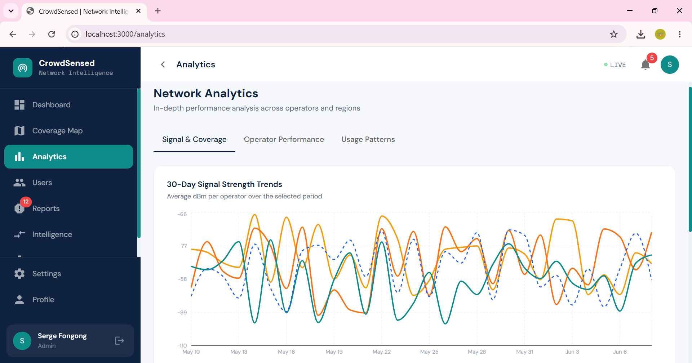

Reports Management with status badges page
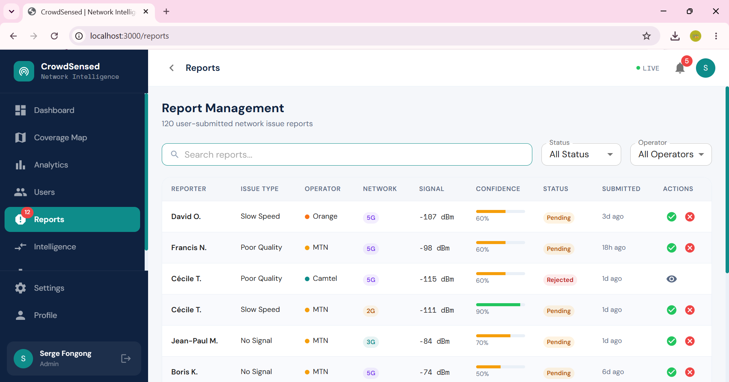

User Management page
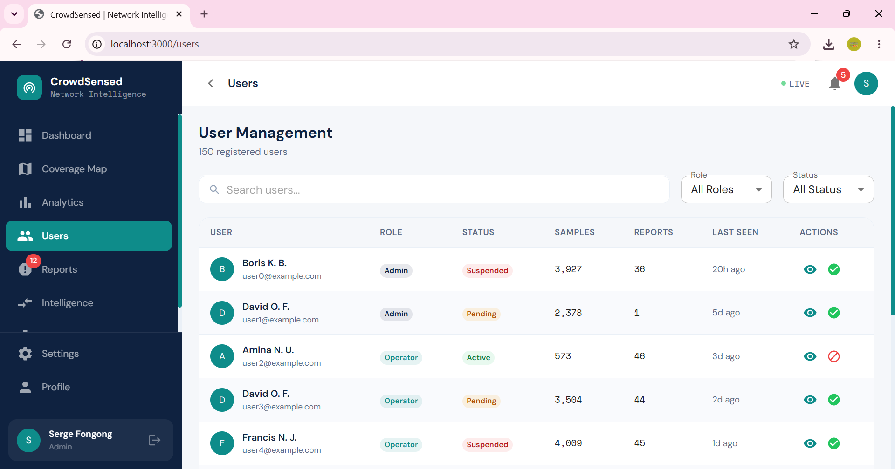

Coverage Intelligence page
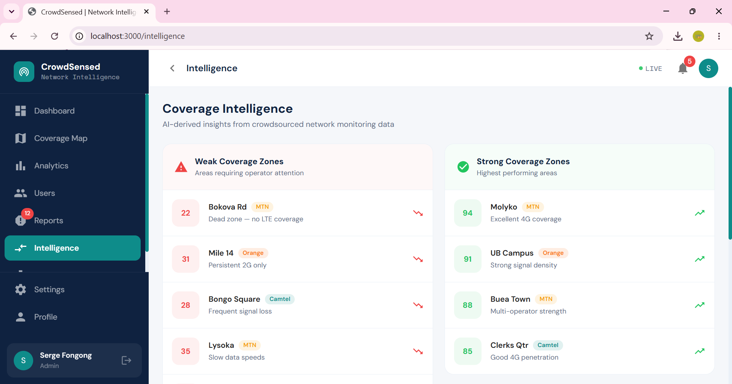

Data Export page
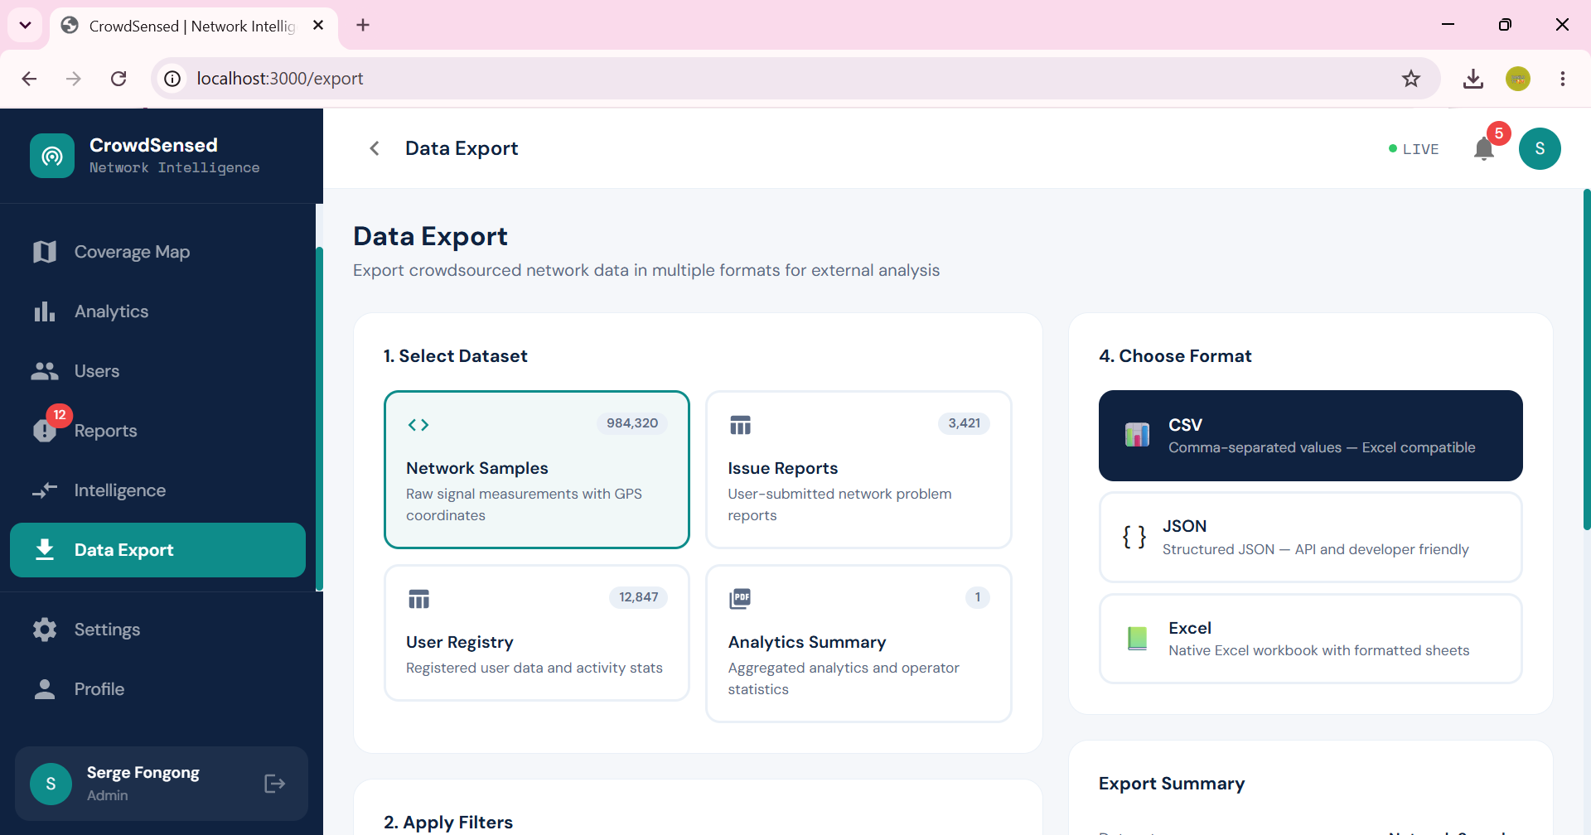

User Profile
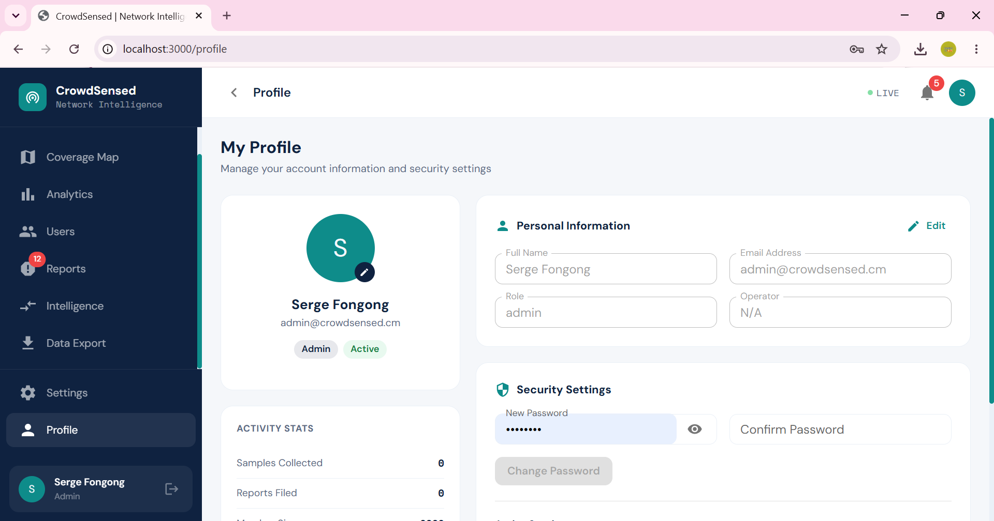

Settings
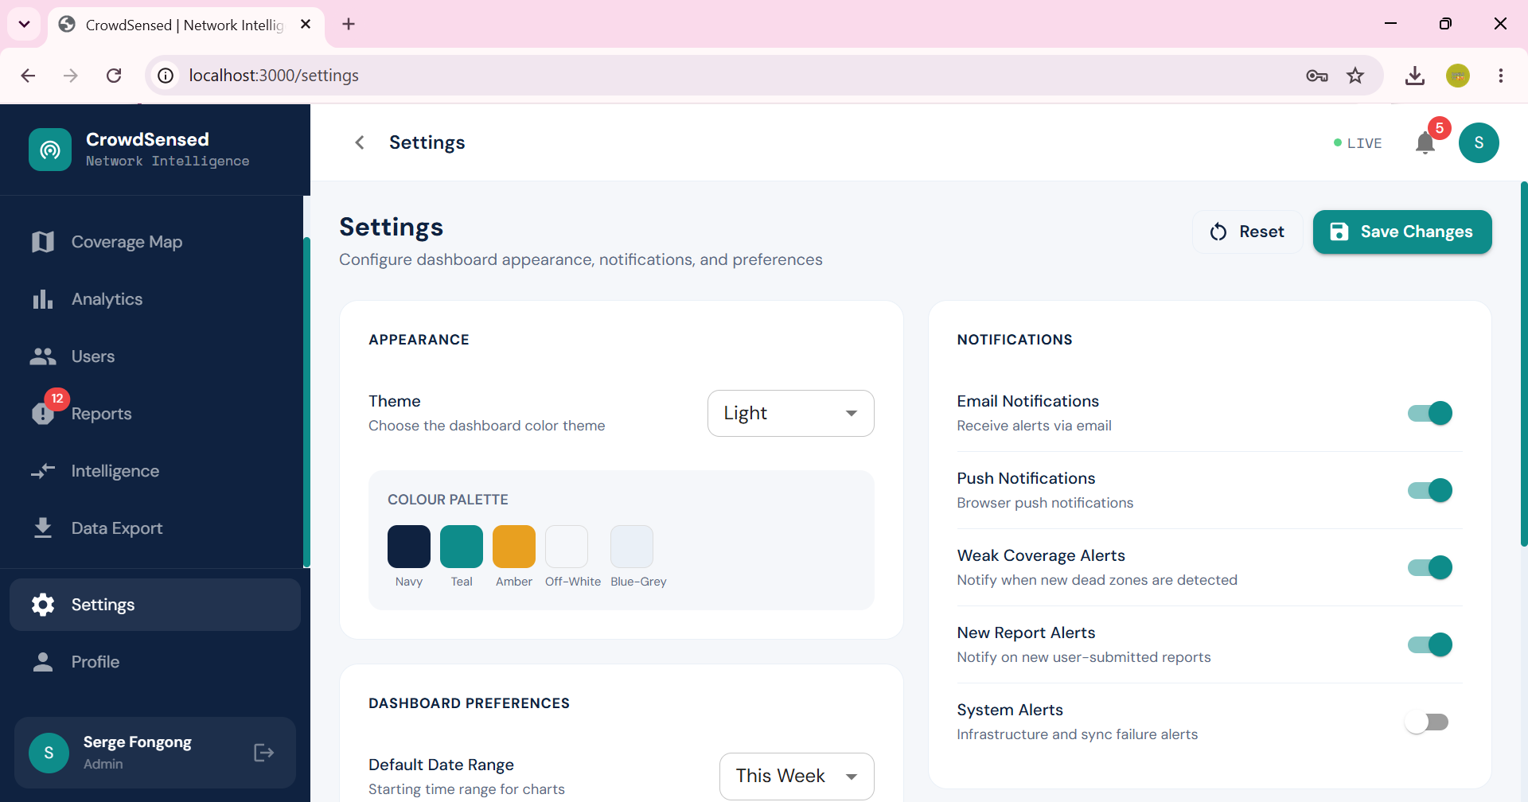
CrowdSensed · Group 7 · FET-UB · 2026

